NOSQL – Afternoon Session: Anish Mathews

***1. Find all hotels with ratings for Cleanliness>=4***

Solution: select address,city from `travel-sample` where type=="hotel" and reviews[*].ratings[*].Cleanliness>=4;

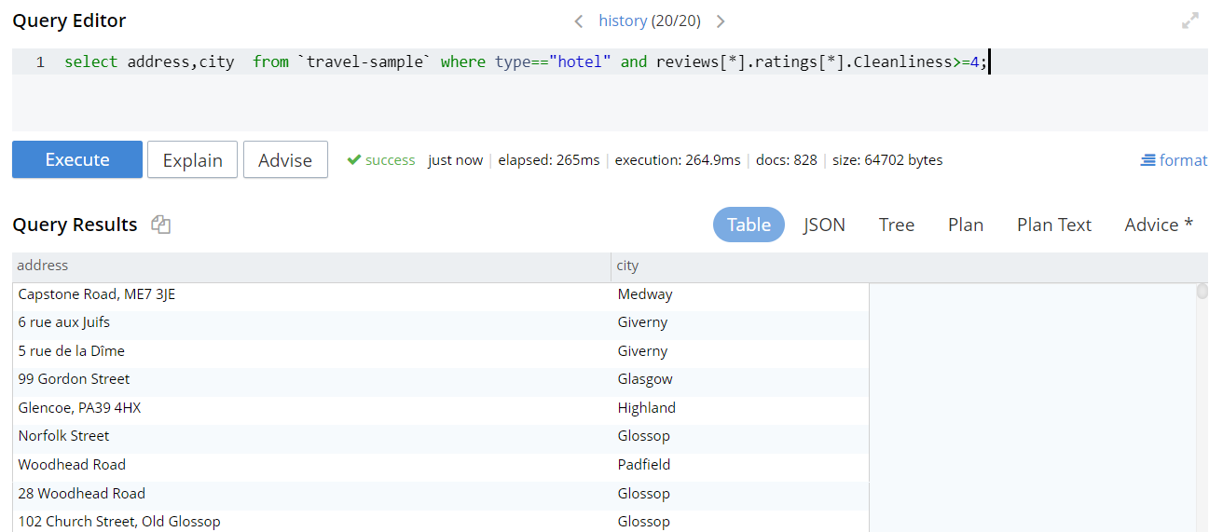

***2. Find the highest airport in each country***

Solution: select country, max(geo.alt) as P from `travel-sample` where type==”airport” group by country

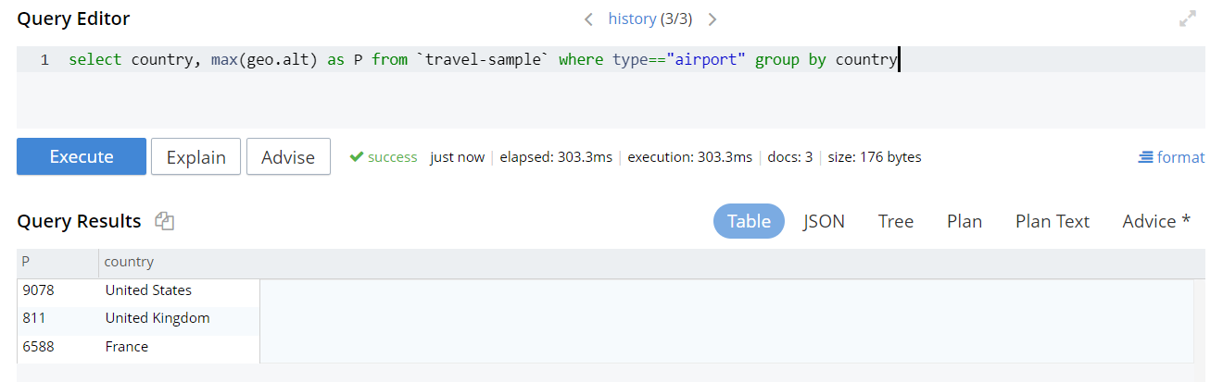

***3. Find all routes operated by Air France from the city of Marseille. (use field faa)***

Solution: select p.airline,p.airlineid from `travel-sample` p where p.type=="route" and p.sourceairport IN SPLIT ((select RAW q.faa from `travel-sample` q where q.type=="airport" and q.city=="Marseille")[0]);

